Platform Deployment Architecture

**Sprint 1: - Create Jenkin AMI using packer and deploy the Jenkin server in AWS using terraform.**

 

**AMI built as per packer template**

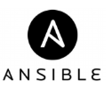

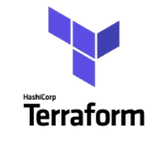 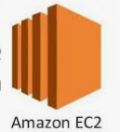

**Provisioning Jenkin Server using AMI**

**Sprint 2:- Deployment of Kubernetes cluster through Jenkin CICD pipeline**

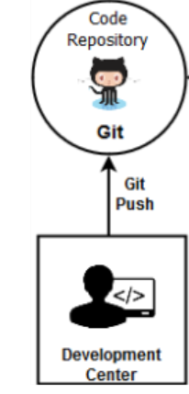 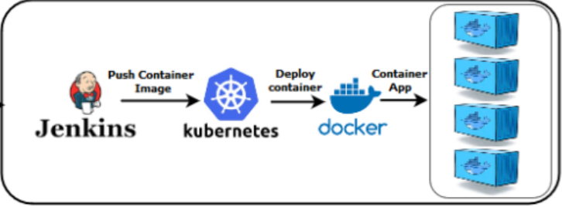

* **AWS PLATFORM**